Subtitle of the deliverable (Calibri 18). Blue colour code R0 G167 B240
Organisation author, Month (Year)
DXY.Z TITLE OF THE DELIVERABLE (CALIBRI 21)
BLACK COLOUR CODE R38 G38 B38

TITLE OF THE REPORT
D11.1: TITLE OF THE DELIVERABLE (CALIBRI 11 in capital leters )
Subtitle of the deliverable (calibri 11 in lowercase)
SUMMARY
Summarise the objectives, methodology, results and findings achieved.Use Calibri 11. Maximum of 15 Lines of total text. Other important findings can be summarised in the executive summary.
Lorem ipsum dolor sit amet, consectetur adipisicing elit, sed do eiusmod tempor incididunt ut labore et dolore magna aliqua. Ut enim ad minim veniam, quis nostrud exercitation ullamco laboris nisi ut aliquip ex ea commodo consequat. Duis aute irure dolor in reprehenderit in voluptate velit esse cillum dolore eu fugiat nulla pariatur. Excepteur sint occaecat cupidatat non proident, sunt in culpa qui officia deserunt mollit anim id est laborum.
"Lorem ipsum dolor sit amet, consectetur adipisicing elit, sed do eiusmod tempor incididunt ut labore et dolore magna aliqua. Ut enim ad minim veniam, quis nostrud exercitation ullamco laboris nisi ut aliquip ex ea commodo consequat. Duis aute irure dolor in reprehenderit in voluptate velit esse cillum dolore ».
Excepteur sint occaecat cupidatat non proident, sunt in culpa qui officia deserunt mollit anim id est laborum."
Lorem ipsum dolor sit amet, consectetur adipisicing elit, sed do eiusmod tempor incididunt ut labore et dolore magna aliqua. Ut enim ad minim veniam, quis nostrud exercitation ullamco laboris nisi ut aliquip
Excepteur sint occaecat cupidatat non proident, sunt in culpa qui officia deserunt mollit anim id est laborum.
"Lorem ipsum dolor sit amet, consectetur adipisicing elit, sed do eiusmod tempor incididunt ut labore et dolore magna aliqua. Ut enim ad minim veniam, quis nostrud exercitation ullamco laboris nisi ut aliquip ex ea commodo consequat. Duis aute irure dolor in reprehenderit in voluptate velit esse cillum dolore ».
Excepteur sint occaecat cupidatat non proident, sunt in culpa qui officia deserunt mollit
DELIVERABLE NUMBER |  | WORK PACKAGE
D12.4 |  | WP12.3
LEAD BENEFICIARY |  | DELIVERABLE AUTHOR(S)
KWR Water Reseach Institute |  | Rossanne Smith (KWR)  Rafael Muñoz (Organisation A)  Ahmed Babbad (Organisation B)
QUALITY ASSURANCE
Rossanne Smith  Rafael Muñoz |  | Organisation C  Organisation D
PLANNED DELIVERY DATE |  | ACTUAL DELIVERY DATE
31/01/2014 |  | 25/07/2014
DISSEMINATION LEVEL | □ PU = Public  □ PP = Restricted to other programme participants  □ RE = Restricted to a group specified by the consortium.  Please specify: _____________________________  □ CO = Confidential, only for members of the consortium

Table of contents

Table of contents II
List of Figures III
List of Tables IV
List of Acronym V
Executive summary 1
1. Demonstration of first level header 2
1.1 Second level header have different color and size 2
1.1.1 Header with text color (third level) 2
1.1.2 How to insert a figure and its source (reference) 2
1.1.3 How to insert a table in the text and its source (reference) 3
1.1.4 How to list with bullet points 3
2. Demonstration of first level header for a second time this also really long to show the line breakage of this header level 4
1.2 Second level header have different color and size 4
1.3 Second level header have different color and size 4
1.4 Second level header have different color and size 4
1.4.1 Some examples of pictures in the middle of the text 4
3. References 6
ANNEX A: Additional information 7

List of Figures

Figure 1: Example of figure: ESS approach scheme linking socio-economics and ecosystems Scheme: MAES, 2014 2
Figure 2: Example of 2 pictures presented together 4
Figure 3: Example of picture to be included in the report 5

List of Tables

Table 1: Example of table based in ESS lists 3

List of Acronyms and Abbreviations

Executive summary

ein et ut dolupta tesequi dolum que eria dolut audici dolo consequate vendae consequi non porem ipsa commoluptur sed qui que nestiam core nis dolesequis poribus, serero bea nos expliciis quam unt veribus velisqu odicita tecturibus, tem ventore rioratur? Qui inulpa dolume nam, sit molore latur? Di cone laut quias dolessed exernatem repro bera nullaborrum aut fuga. Et autem eliquiderum facepre, aceptat latius prae reperrum es.
Dolum que eria dolut audici dolo consequate vendae consequi non porem ipsa commoluptur sed qui que nestiam core nis dolesequis poribus, serero bea nos expliciis quam unt veribus velisqu odicita tecturibus, tem ventore rioratur? Qui inulpa dolume nam, sit molore latur? Di cone laut quias dolessed exernatem repro bera nullaborrum aut fuga. Et autem eliquiderum facepre, aceptat latius prae reperrum es ein et ut dolupta tesequi dolum que eria dolut audici dolo consequate vendae consequi non porem ipsa commoluptur sed qui que nestiam core nis dolesequis poribus, serero bea nos expliciis quam unt veribus velisqu odicita tecturibus, tem ventore rioratur? Qui inulpa dolume nam, sit molore latur? Di cone laut quias dolessed exernatem repro bera nullaborrum aut fuga. Et autem eliquiderum facepre, aceptat latius prae reperrum es
Queria dolut audici dolo consequate vendae consequi non porem ipsa commoluptur sed qui que nestiam core nis dolesequis poribus, serero bea nos expliciis quam unt veribus velisqu odicita tecturibus, tem ventore rioratur? Qui inulpa dolume nam, sit molore latur? Di cone laut quias dolessed exernatem repro bera nullaborrum aut fuga. Et autem eliquiderum facepre, aceptat latius prae reperrum es

Demonstration of first level header

Second level header have different color and size

Sin et ut dolupta tesequi dolum que eria dolut audici dolo consequate vendae consequi non porem ipsa commoluptur sed qui que nestiam core nis dolesequis poribus, serero bea nos expliciis quam unt veribus velisqu odicita tecturibus, tem ventore rioratur? Qui inulpa dolume nam, sit molore latur? Di cone laut quias dolessed exernatem repro bera nullaborrum aut fuga. Et autem eliquiderum facepre, aceptat latius prae reperrum es

Header with text color (third level)
Tesequi dolum que eria dolut audici dolo consequate vendae consequi non porem ipsa commoluptur sed qui que nestiam core nis dolesequis poribus, serero bea nos expliciis quam unt veribus velisqu odicita tecturibus, tem ventore rioratur? Qui inulpa dolume nam, sit molore latur? Di cone laut quias dolessed exernatem repro bera nullaborrum aut fuga. Et autem eliquiderum facepre, aceptat latius prae reperrum es Dolut audici dolo consequate vendae consequi non porem ipsa commoluptur sed qui que nestiam core nis dolesequis poribus, serero bea nos expliciis quam unt veribus velisqu odicita tecturibus, tem ventore rioratur? Qui inulpa dolume nam, sit molore latur? Di cone laut quias dolessed exernatem repro bera nullaborrum aut fuga. Et autem eliquiderum facepre, aceptat latius prae reperrum es

How to insert a figure and its source (reference)
agnimpe repedios voluptam fuga. Re ab ipsae same voluptatem ilia atectum que voluptibea volore, officia testotati de doloria quos quibusa dis asim voluptatem. Nequiasi que volorrum re, ulpa dolecest accus.
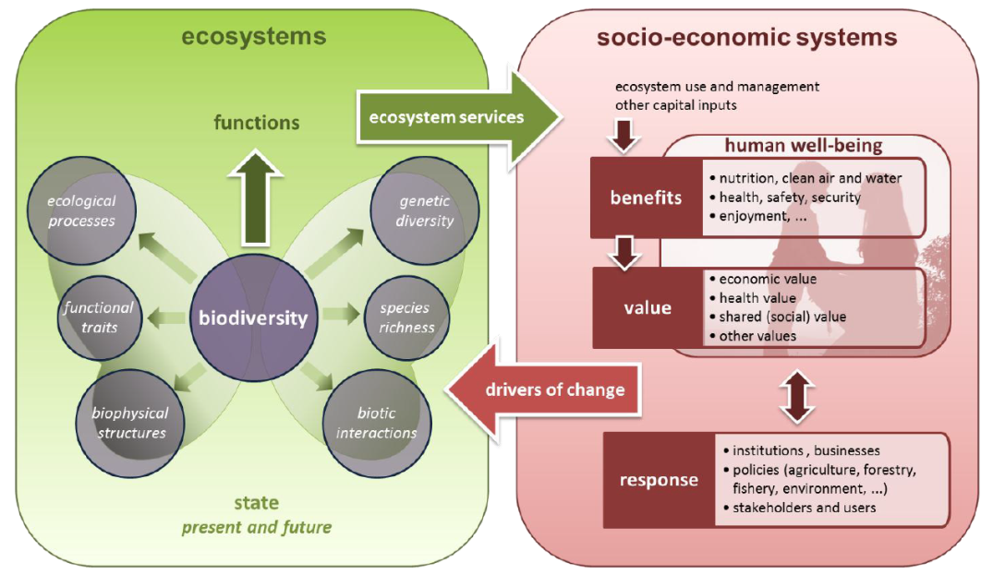

Figure 1: Example of figure: ESS approach scheme linking socio-economics and ecosystems Scheme: MAES, 2014

How to insert a table in the text and its source (reference)
agnimpe repedios voluptam fuga. Re ab ipsae same voluptatem ilia atectum que voluptibea volore, officia testotati de doloria quos quibusa dis asim voluptatem. Nequiasi que volorrum re, ulpa dolecest accus.
Table 1: Example of table based in ESS lists
Source: https://www.mfe.govt.nz
System | Goods | Services
Agricultural ecosystems | Food crops  Fibre crops  Crop genetic resources  Flowers | Maintain limited watershed functions (infiltration, flow control, partial soil protection)  Provide habitat for birds, pollinators and soil organisms important to agriculture  Uses atmospheric carbon to form plant material  Provide employment  Provide land for absorption of treated wastewater
Coastal ecosystems | Fish and shellfish  Fish-meal (animal feed)  Seaweeds  Genetic resources | Provide moderate storm impact protection (mangroves, barrier islands)  Provide wildlife (marine and terrestrial) habitat  Maintain biodiversity  Dilute and treat wastes, including wastewater  Provide harbours and transportation routes  Provide human habitat  Provide employment  Contribute to aesthetic beauty and provide recreation
Freshwater ecosystems | Drinking and irrigation water  Fish  Hydro-electricity  Watercress  Genetic resources  Recreation | Buffer water flow (control timing and volume)  Dilute and carry away wastes, including wastewater  Cycle nutrients  Maintain biodiversity  Provide aquatic habitat  Provide transportation corridor  Provide employment  Contribute to aesthetic beauty and Provide recreation

How to list with bullet points
Sin et ut dolupta tesequi dolum que eria dolut audici dolo consequate vendae consequi non porem ipsa commoluptur sed qui que nestiam core nis dolesequis poribus, serero bea nos expliciis quam unt veribus velisqu odicita tecturibus, tem ventore rioratur? Qui inulpa dolume nam, sit molore latur? Di cone laut quias dolessed exernatem repro bera nullaborrum aut fuga. Et autem eliquiderum facepre, aceptat latius prae reperrum es
- dolupta spernatur, untem nonserum deriosa
  - preribus doluptatem repuda
  - doluptis aut odictatque velignam
  - consecate audam endit ut mos

Demonstration of first level header for a second time this also really long to show the line breakage of this header level

Second level header have different color and size
Sin et ut dolupta tesequi dolum que eria dolut audici dolo consequate vendae consequi non porem ipsa commoluptur sed qui que nestiam core nis dolesequis poribus, serero bea nos expliciis quam unt veribus velisqu odicita tecturibus, tem ventore rioratur? Qui inulpa dolume nam, sit molore latur? Di cone laut quias dolessed exernatem repro bera nullaborrum aut fuga. Et autem eliquiderum facepre, aceptat latius prae reperrum es
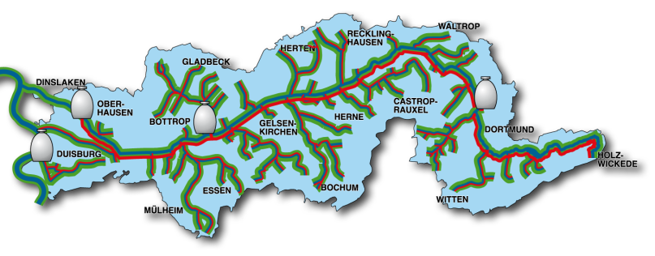
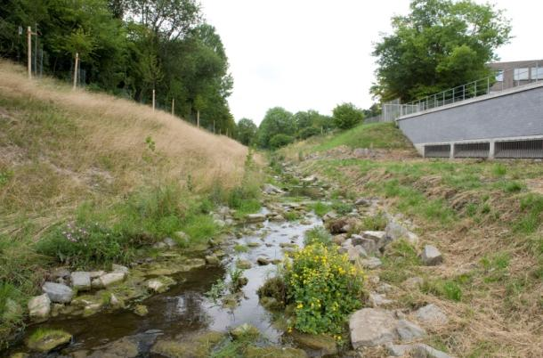

Figure 2: Example of 2 pictures presented together
Left view after the restoration Source: CETaqua. Right: Map of locations of the facilities

Second level header have different color and size
Sin et ut dolupta tesequi dolum que eria dolut audici dolo consequate vendae consequi non porem ipsa commoluptur sed qui que nestiam core nis dolesequis poribus, serero bea nos expliciis quam unt veribus velisqu odicita tecturibus, tem ventore rioratur? Qui inulpa dolume nam, sit molore latur? Di cone laut quias dolessed exernatem repro bera nullaborrum aut fuga. Et autem eliquiderum facepre, aceptat latius prae reperrum es

Second level header have different color and size

Some examples of pictures in the middle of the text
Sin et ut dolupta tesequi dolum que eria dolut audici dolo consequate vendae consequi non porem ipsa commoluptur sed qui que nestiam core nis dolesequis poribus, serero bea nos expliciis quam unt veribus velisqu odicita tecturibus, tem ventore rioratur? Qui inulpa dolume nam, sit molore latur? Di cone laut quias dolessed exernatem repro bera nullaborrum aut fuga. Et autem eliquiderum facepre, aceptat latius prae reperrum es
Sin et ut dolupta tesequi dolum que eria dolut audici dolo consequate vendae consequi non porem ipsa commoluptur sed qui que nestiam core nis dolesequis poribus, serero bea nos expliciis quam unt veribus velisqu odicita tecturibus, tem ventore rioratur? Qui inulpa dolume nam, sit molore latur? Di cone laut quias dolessed exernatem repro bera nullaborrum aut fuga. Et autem eliquiderum facepre, aceptat latius.
Sin et ut dolupta tesequi dolum que eria dolut audici dolo consequate vendae consequi non porem ipsa commoluptur sed qui que nestiam core nis dolesequis poribus, serero bea nos expliciis quam unt veribus velisqu odicita tecturibus, tem ventore rioratur? Qui inulpa dolume nam, sit molore latur? Di cone laut quias dolessed exernatem repro bera nullaborrum aut fuga. Et autem eliquiderum facepre, aceptat latius prae reperrum es. Sin et ut dolupta tesequi dolum que eria dolut audici dolo consequate vendae consequi non porem ipsa commoluptur sed qui que nestiam core nis dolesequis poribus, serero bea nos expliciis quam unt veribus velisqu odicita tecturibus, tem ventore rioratur? Qui inulpa dolume nam, sit molore latur? Di cone laut quias dolessed exernatem repro bera nullaborrum aut fuga. Et autem eliquiderum facepre, aceptat latius prae reperrum
Te dolum que eria dolut audici dolo consequate vendae consequi non porem ipsa commoluptur sed qui que nestiam core nis dolesequis poribus, serero bea nos expliciis quam unt veribus velisqu odicita tecturibus, tem ventore rioratur? Qui inulpa dolume nam, sit molore latur? Di cone laut quias dolessed exernatem repro bera Sin et ut dolupta tesequi dolum que eria dolut audici dolo consequate vendae consequi non porem ipsa commoluptur sed qui que nestiam core nis dolesequis poribus, serero bea nos expliciis quam unt veribus velisqu odicita tecturibus, tem ventore rioratur? Qui inulpa dolume nam, sit molore latur? Di cone laut quias dolessed exernatem repro bera nullaborrum aut fuga. Et autem eliquiderum facepre, aceptat latius prae reperrum es

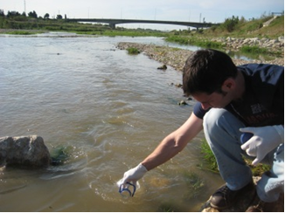

Figure 3: Example of picture to be included in the report
Source: CETaqua

Sin et ut dolupta tesequi dolum que eria dolut audici dolo consequate vendae consequi non porem ipsa commoluptur sed qui que nestiam core nis dolesequis poribus, serero bea nos expliciis quam unt veribus velisqu odicita tecturibus, tem ventore rioratur? Qui inulpa dolume nam, sit molore latur? Di cone laut quias dolessed exernatem repro bera nullaborrum aut fuga. Et autem eliquiderum facepre, aceptat latius prae reperrum es
Sin et ut dolupta tesequi dolum que eria dolut audici dolo consequate vendae consequi non porem ipsa commoluptur sed qui que nestiam core nis dolesequis poribus, serero bea nos expliciis quam unt veribus velisqu odicita tecturibus, tem ventore rioratur? Qui inulpa dolume nam, sit molore latur? Di cone laut quias dolessed exernatem repro bera nullaborrum aut fuga. Et autem eliquiderum facepre, aceptat latius prae reperrum es

References

Baumgarten, B., Jährig, J., Reemtsma, T., Jekel, M., (2011). Long term laboratory column experiments to simulate bank ﬁltration: factors controlling removal of sulfamethoxazole. Water Research 45, 211 - 220.
Bertelkamp, C.; Reungoat, J.; Cornelissen, E. R.; Singhal, N.; Reynisson, A.J.; van der Hoek, J.P.; Verliefde A.R.D. (2013). Sorption and biodegradation of organic micropollutants during river bank ﬁltration: A laboratory column study. Water Research XXX (2013) I – II.
Brandes, O., Nowlan L. and Paris, K. (2008). Going With the Flow? Evolving Water Allocations and the Potential and Limits of Water Markets in Canada. The Conference Board of Canada.
Brandes, Oliver and Curran, Deborah (2009). Setting a New Course in British Columbia – Water Governance Reform Options and Opportunities, POLIS Discussion Paper 09-02, Victoria, BC.
European Commission 2010: Communicating research for evidence-based policymaking, A practical guide for researchers in socio-economic sciences and humanities; European Commission, Directorate-General for Research, Socio-economic Sciences and Humanities; Publications Office of the European Union, Luxembourg.
Hebig ,K. H.; Nödler, K.; Licha, T.; Scheytt, T.J. (2014). Impact of materials used in lab and field experiments on the recovery of organic micropollutants. Science of the Total Environment 473-474 (2014) 125-131.
Hillebrand, O.; Musallam, S.; Scherer, L.; Nödler, K.; Licha, T. (2013). The challenge of sample-stabilisation in the era of multi-residue analytical methods: A practical guideline of the stabilization of 46 organic micropollutants in aqueous samples. Science of the Total Environment 454-455 (3013) 289 – 298.
Sauchyn, D et al. 2009. Chapter 3. Upland watershed management and global change. Canada's Rocky Mountains and western plains. In: Managing Water Resources in a Time of Global Change. Mountains, Valleys and Flood Plains. Edited by A. Garrido and A. Dinar. Routledge. 32-49.

ANNEX A: Additional information

